Milestone 1: Define Problem / Problem Understanding

Activity 1: Specify the business problem Refer Project Description

Activity 2: Business requirements The business requirements for analyzing the performance and efficiency of banks in world include identifying KPIs, comparing performance across different countries and states, identifying patterns and trends over time, identifying affecting factors, creating interactive dashboards and reports, identifying areas for improvement, making data-driven decisions, comparing to the industry average and creating forecasting models for future performance. The ultimate goal is to gain insights and improve performance through data visualization techniques.

Activity 3: Literature Survey (Student Will Write) A literature survey for the financial analysis of banks would involve researching and reviewing previous studies, articles, and reports on the topic. This could include information on the methods and techniques used for financial analysis of banks, as well as the results and conclusions of these studies. Some potential areas of focus for a literature survey on financial analysis of banks could include: Ratio analysis, which involves comparing different financial metrics (such as return on assets, return on equity, etc.) to assess a bank's performance and compare it to industry averages or other benchmarks. Stress testing, which involves simulating adverse economic scenarios to evaluate a bank's ability to withstand financial shocks. Risk management, which involves identifying, assessing, and mitigating the various risks facing a bank, such as credit risk, market risk, and operational risk. Basel III, which is a set of international regulatory standards for banks that includes measures for capital adequacy, liquidity, and leverage.

Activity 4: Social or Business Impact. Social Impact: Financial analysis of banks can have a significant social impact by identifying areas where the bank's operations or lending practices may be causing harm to vulnerable communities or perpetuating inequality. For example, a financial analysis might reveal that a bank is heavily invested in fossil fuel companies, contributing to climate change, or that the bank is disproportionately denying loans to minority-owned businesses, perpetuating economic discrimination Business Model/Impact: Financial analysis of banks can have a significant impact on the business operations of the bank itself and its competitors. For example, a financial analysis can help the bank identify areas where it is underperforming compared to its peers, such as in terms of profitability or asset quality. This information can then be used to develop strategies for improving the bank's performance, such as by reducing costs, increasing revenue, or improving risk management practices.

Milestone 2: Data Collection & Extraction from Database Data collection is the process of gathering and measuring information on variables of interest, in an established systematic fashion that enables one to answer stated research questions, test hypotheses, evaluate outcomes and generate insights from the data.

Activity 1: Downloading the dataset Please use the link to download the dataset:

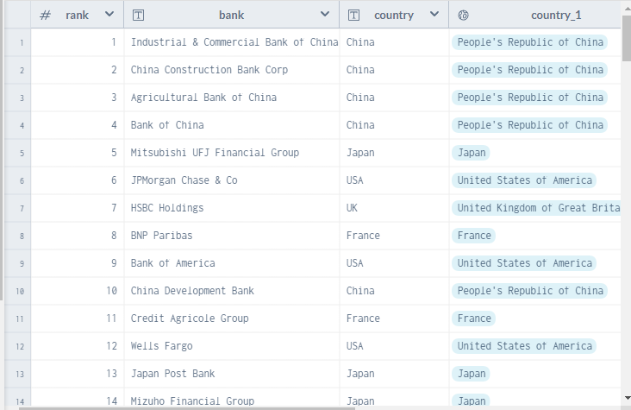

Activity 1.1: Understand the data Data contains all the meta information regarding the columns described in the CSV files Column Description of the Dataset:

1. bank: Name of the bank

2. Country: In which country the bank is operating

3. Total Assest: Total assets of the banks

4. Rank : Rank of the bank among the world

5. landmass : Under which continent the bank belongs to

Activity 2: Storing Data in DB & Perform SQL Operations Explanation video link:

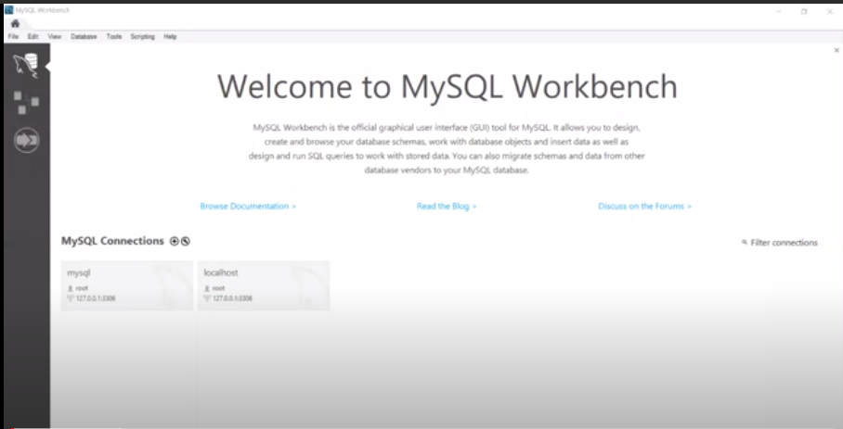

Activity 3: Connect DB with Tableau Explanation video link

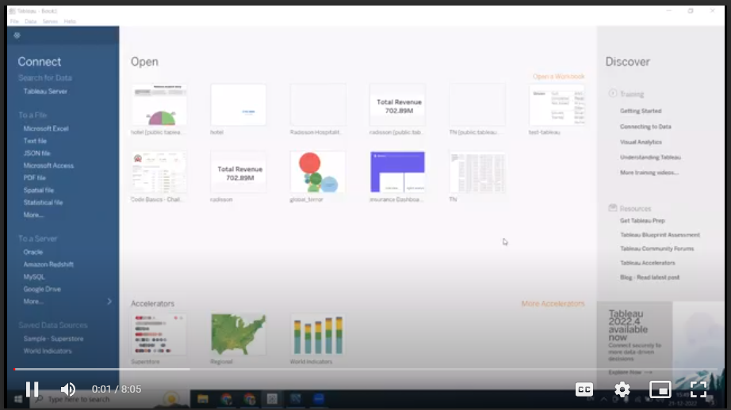

Milestone 3: Data Preparation

Activity 1: Prepare the Data for Visualization Preparing the data for visualization involves cleaning the data to remove irrelevant or missing data, transforming the data into a format that can be easily visualized, exploring the data to identify patterns and trends, filtering the data to focus on specific subsets of data, preparing the data for visualization software, and ensuring the data is accurate and complete. This process helps to make the data easily understandable and ready for creating visualizations to gain insights into the performance and efficiency. Explanation video link 1:

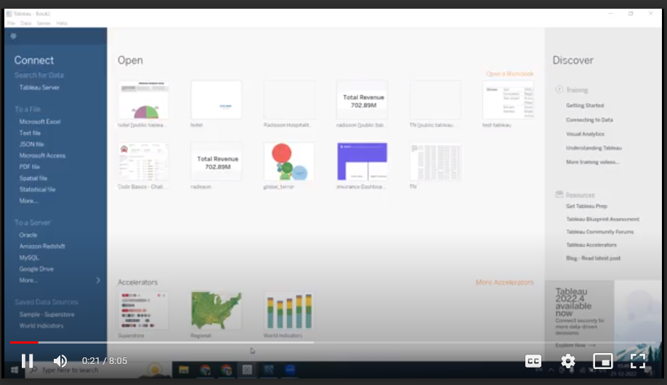

Milestone 4: Data Visualization Data visualization is the process of creating graphical representations of data to help people understand and explore the information. The goal of data visualization is to make complex data sets more accessible, intuitive, and easier to interpret. By using visual elements such as charts, graphs, and maps, data visualizations can help people quickly identify patterns, trends, and outliers in the data.

Activity 1: No of Unique Visualizations The number of unique visualizations that can be created with a given dataset. Some common types of visualizations that can be used to analyze the performance and efficiency of banks include bar charts, line charts, heat maps, scatter plots, pie charts,Maps etc. These visualizations can be used to compare performance, track changes over time, show distribution, and relationships between variables, breakdown of revenue and customer demographics, workload, resource allocation and location of banks.

Activity 1.1 : Top banks according rank and assets Explanation video link:

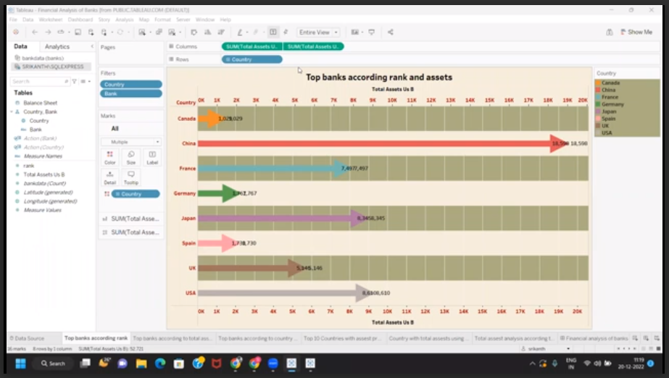

Milestone 5: Dashboard A dashboard is a graphical user interface (GUI) that displays information and data in an organized, easy-to-read format. Dashboards are often used to provide real-time monitoring and analysis of data and are typically designed for a specific purpose or use case. Dashboards can be used in a variety of settings, such as business, finance, manufacturing, healthcare, and many other industries. They can be used to track key performance indicators (KPIs), monitor performance metrics, and display data in the form of charts, graphs, and tables.

Activity 1- Responsive and Design of Dashboard Once you have created views on different sheets in Tableau, you can pull them into a dashboard. Explanation video link:

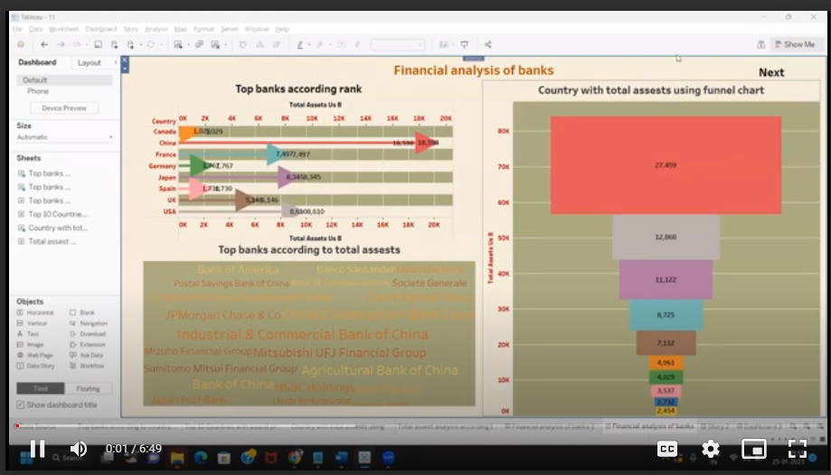

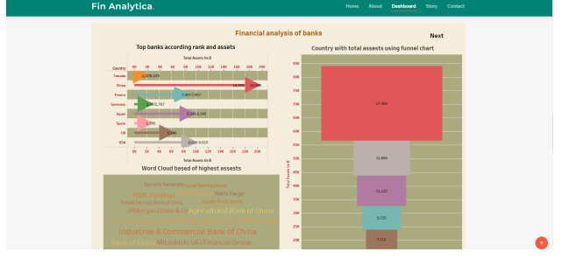

Milestone 6: Story A data story is a way of presenting data and analysis in a narrative format, intending to make the information more engaging and easier to understand. A data story typically includes a clear introduction that sets the stage and explains the context for the data, a body that presents the data and analysis logically and systematically, and a conclusion that summarizes the key findings and highlights their implications. Data stories can be told using a variety of mediums, such as reports, presentations, interactive visualizations, and videos.

Activity 1- No of Scenes of Story The number of scenes in a storyboard for a data visualization analysis of the performance of banks will depend on the complexity of the analysis and the specific insights that are trying to be conveyed. A storyboard is a visual representation of the data analysis process and it breaks down the analysis into a series of steps or scenes. Explanation video link:

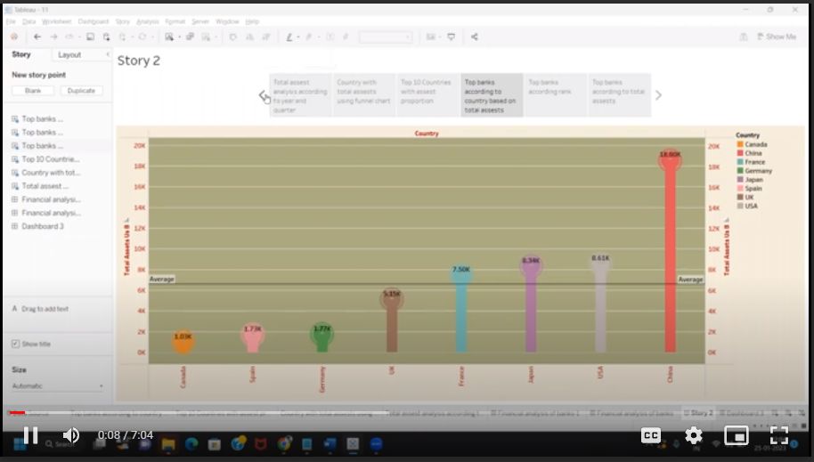

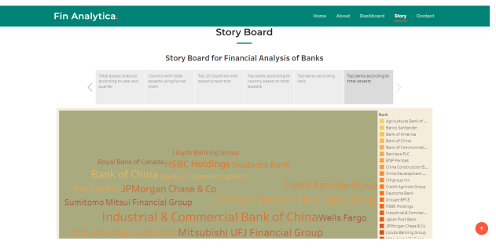

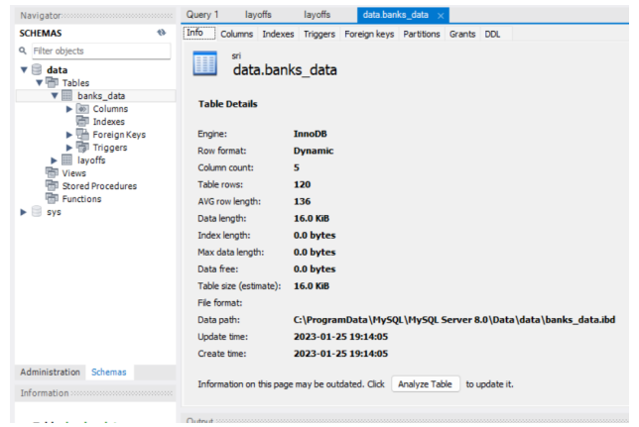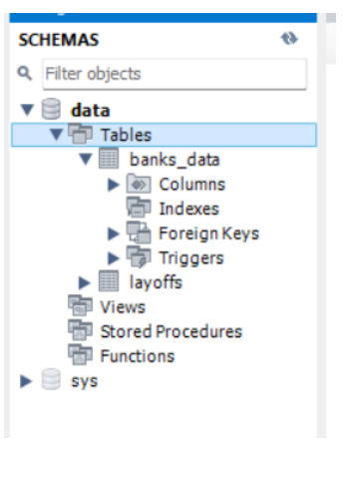

Activity 2: Utilization of Data Filters

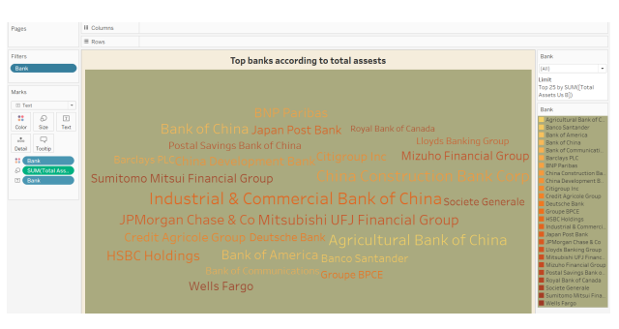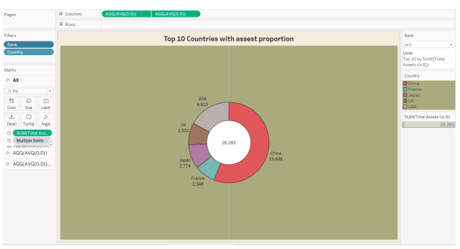

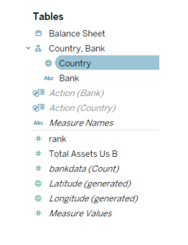

Activity 4: No of Visualizations/ Graphs

1. Top banks according rank and assets

2. Top banks according to total assets

3. Top banks according to country based on total assets

4. Top 10 Countries with assets proportion

5. Country with total assets using funnel chart in increasing order

6. Total assets analysis according to year and quarter

Milestone 8: Web integration Publishing helps us to track and monitor key performance metrics and to communicate results and progress. help a publisher stay informed, make better decisions, and communicate their performance to others. Publishing dashboard and reports to tableau public

Step 1: Go to Dashboard/story, click on the share button on the top ribbon

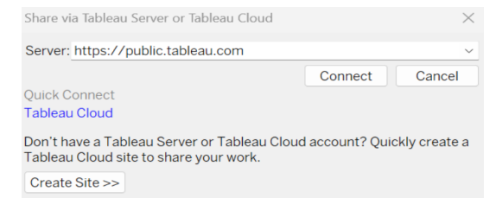

Step 2: Once you click on connect it will ask you for the tableau public username and password

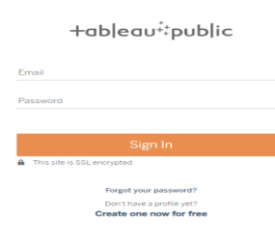

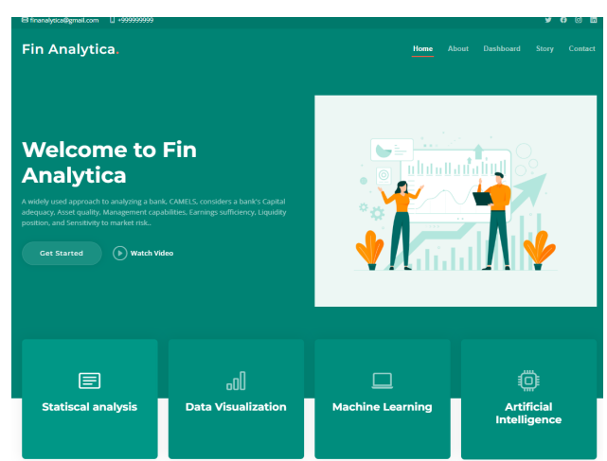

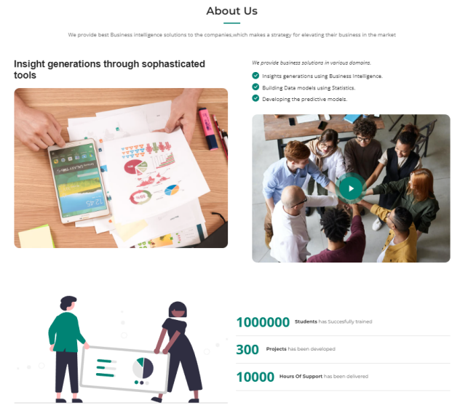

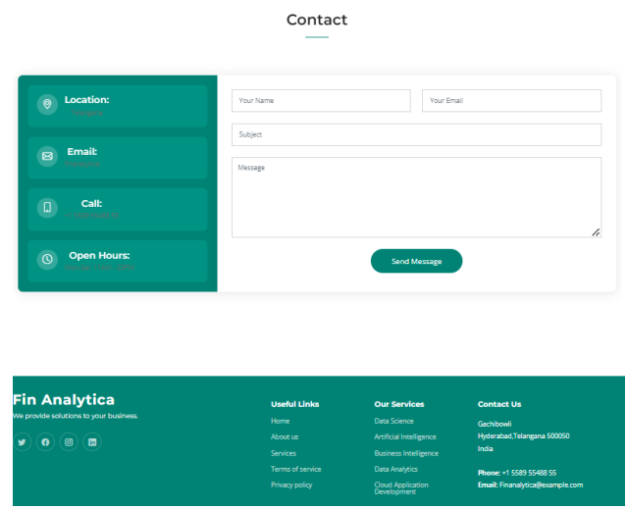

Milestone 9: Project Demonstration & Documentation Below mentioned deliverables to be submitted along with other deliverables

Activity 1:- Record explanation Video for the project's end-to-end solution

Activity 2:- Project Documentation-Step by step project development procedure